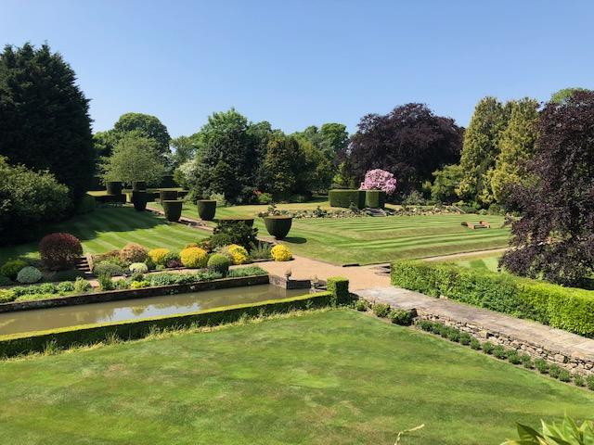
On Sunday May 26th, Henden Manor garden will be open from 3.30 to 6.30. Please join us for a stroll around the 8-acre garden, open for the first time in 30 years. Join us for wine and canapes, and a chance to win a raffle prize in support of the Sundridge & Ide Hill Branch of the Sevenoaks Conservative Association. All members and their friends and family are most welcome. Ample parking available.
Direction: Henden Manor Estate is located at the foot of Ide Hill. Proceed down Ide Hill towards Edenbridge, continue on the road around the turn at Bough Beech junction and carry on towards Edenbridge for half a mile, you will see the entrance to Henden Manor Estate on the right at the next sharp left-hand turn.
Please contact the Branch Secretary Maria Lewington on 01959 562588 or, m_lewington@sky.com ,Roni Lovegrove, Chairman, at. roni.lovegrove@btinternet.com
Please book by May 23rd.
Yes, I would like …………………. tickets at £10 each
Name………………………………………………………………………………
Address……………………………………………………………………………….
Post Code……………………… Phone ……………………………………. or email………………………………………….
Please send your cheque payable to SCA Sundridge & Ide Hill to:
Maria Lewington, Herons Reach, 64 Main Road, Sundridge, TN14 6ER,

