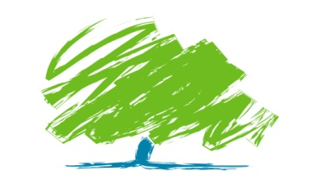

Sevenoaks Conservative Association
Otford & Shoreham Branch

Summer is here come and join
us at our Hog Roast BBQ

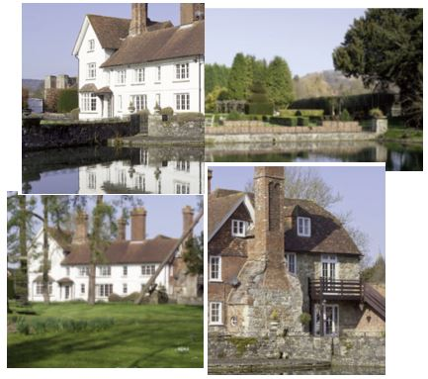

In the grounds of

The Castle House, Otford

Castle House is a listed property dating from the 15th century hidden away in the heart of the
attractive village of Otford. The grounds centre around two lakes and include a rose garden,
parterre, espaliered fruit trees and lawns set in over 10 acres of grounds.

Sunday 8th July 2018 from midday

* Please note that the two lakes are not fenced and we advise that children are supervised.

Please complete form below (capitals please). £20 per person & £10 for children
-------------------------------------------------------------------------------------------------------
I would like to book .......... ticket(s) @ £20 per person and .......... ticket(s) @ £10 for children. I enclose a cheque for ............................... made payable to Sevenoaks Conservative Association or bank transfer to:
Otford & Shoreham Branch: sort code: 40-40-32, account: 40247278.

Name: ........................................................... Address: ..............................................................................................
.....................................................................................................................................................................................

Please email completed form to: oastbrook@yahoo.co.uk or send with cheque to: Oastbrook,Telston Lane, Otford TN14 5JZ. If you would like to provide an email address we can email your ticket(s): ...............................................
For further information or queries please use email address or call: 01959 525610/522503.

