Sevenoaks Conservative Association
Sundridge & Ide Hill Branch
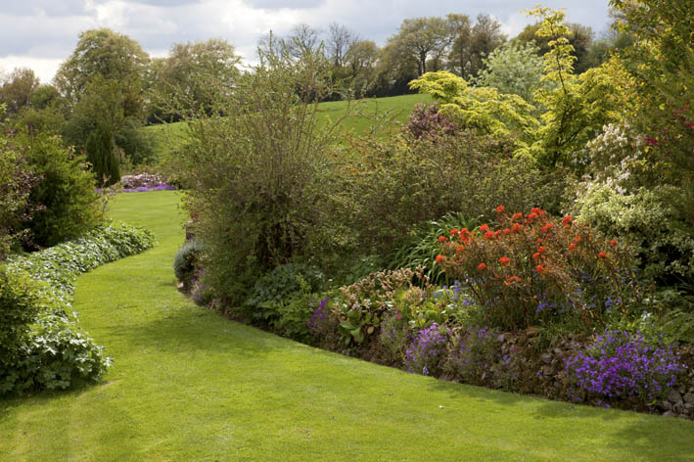
This year on May 20th, 2018 between 4.30-7.30 pm you are invited to visit the stunning gardens of Meadow House, Kent Life magazine’s winner of ‘the Kent Garden of the Year in 2014’
Please join us for wine and canapés celebrating the Royal Wedding while enjoying the 2 acre garden in rhododendron flowering time with glorious views
Ample parking is available.
All members and friends and family are welcome.

Please contact: Branch Secretary Maria Lewington on:
01959 562588 m_lewington@sky.com
Robert Piper: Chairman 01732 455355
Robertpiper3@hotmail.com
Meadow House - direction take A25 to Brasted , turn L into Chart Lane , pass Fox & Hounds towards Toys Hill , Sharp L onto Scords Lane, and destination on the Right .

Acceptance form (please book by 10th May 2018)
Yes, I would like .........tickets at £10.00 each, for 20th May 2018
Name:
Address...........................................................................
Post Code..................................phone...................
Email
Please send your cheque payable to; SCA Sundridge & Ide Hill
To Maria Lewington: Herons Reach 64 Main Road Sundridge
TN14 6ER

